13.3.2 Editors - Video Sequence Editor - Sidebar - Preview - View tab
View Settings Tab 2
View Settings Panel 2
Channel 2
Show Overexposed 2
Proxy Render Size 2
Prefetch Frames 2
Zoom to Fit 2
Frame Overlay Panel 2
Set Overlay Region 3
Frame offset 3
Overlay Type 3
Overlay Lock 3
Save Areas panel 3
Title Safe Margins X/Y 3
Action Safe Margins X/Y 3
Center-Cut Safe Areas 3
Center Title Safe Margins X/Y 4
Scene Strip Display panel 4
Shading 4
Override scene settings 4
Annotations panel 4
Annotations prop 4
Dropdown box 4
Edit Box 4
Fake User 4
Add Annotation 4
Delete Annotation 5
List of Annotation Strokes 5
Thickness 5
Frame Locked/Unlocked 5
Marker Options panel 5
View Options panel 5
Show Metadata 5
Metadata panel 5

View Settings Tab

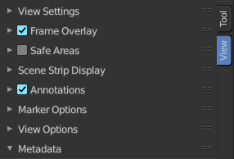
In the View Settings tab you will find the display related settings.

View Settings Panel

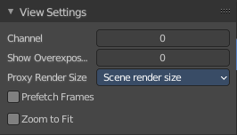
Channel
Which channel number to show in the image preview. The value 0 is the result of all strips combined.

Show Overexposed
Shows overexposed (bright white) areas using a zebra pattern. The threshold can be adjust with the slider.

Proxy Render Size
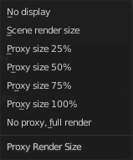
Size to display proxies at in the preview region. Using a smaller preview size will increase speed.
Proxies is a simplified dataset to speed up workflow.

Prefetch Frames
Render frames ahead of current frame in the background for faster playback.

Zoom to Fit
Automatically zoom preview image to fully fit into the preview window. Note that zooming in or out turns off the feature then.

Frame Overlay Panel
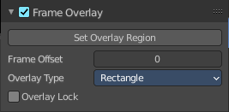
Display a overlay on top of the sequencer with a frame offset of the content.

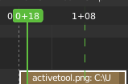
When the feature is active then you will see a green dashed line in the sequencer timeline.

Set Overlay Region
Box select a portion of the viewport to display the overlay content.

Frame offset
What offset frame to use, relative to the current frame position.

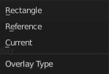
Overlay Type
The overlay draw type.

Overlay Lock
Locks the overlay frame to the current frame. It will not go ahead when you play the video.

Save Areas panel

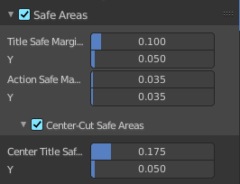
Modern lcd or plasma monitors usually doesn't have overscan areas anymore. But especially older tv screens still may have varying amounts of overscan. And cuts quite a bit content away at the border. And so not all content is shown at all monitors. Safe areas is the area that is always visible at all hardware.

Safe areas are guides to ensure that the most important parts of the content can be seen across all screens. The lines are unfortuantely a bit hard to see when you are in camera view. They mark the safe areas.
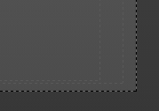
Safe areas can be set from the Camera and Sequencer views.

Tip! Each country sets a legal standard for broadcasting. These include also specific values for safe areas. Bforartists defaults for safe areas follow the EBU (European Union) standard. Make sure you are using the correct values when working for broadcast to avoid any trouble.

Title Safe Margins X/Y
Also known as Graphics Safe. Information (graphics or text) inside this area can be seen by the majority of viewers.

Action Safe Margins X/Y
An extra “margin” for the screen, which can be used to keep elements from piling up against the edges.

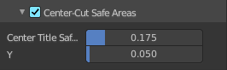
Center-Cut Safe Areas
Center-cuts are a second set of safe areas to ensure content is seen correctly on screens with a different aspect ratio. Old TV sets receiving 16:9 or 21:9 video will cut off the sides. Position content inside the center-cut areas to make sure the most important elements of your composition can still be visible in these screens.

Center Title Safe Margins X/Y
Information (graphics or text) inside this area can be seen by the majority of viewers.

Scene Strip Display panel

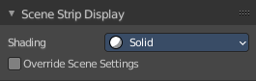
Settings for the strip type Scene Strip.

Shading
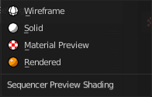
How to display the scene content in the preview window.

Override scene settings
Use the workbench render settings from the sequencer scene instead of the settings instead of each individual scene used in the strip.

Annotations panel

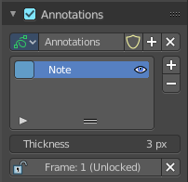
Manage the Annotation layers and materials.


When you don't have drawn a annotation yet then the panel just contains a New button.

Annotations prop

Add, remove and rename new annotations.

Dropdown box

A list of the available annotation layers.

Edit Box
The name of the current annotation. You can rename the annotation to your needs here.

Fake User
Assign a fake user to this annotation. Fake users is a odd concept to keep data in the scene even if it has no user somewhere. The fake user is then a dummy user so that the object is not deleted when saving the scene.

Add Annotation
Add a new annotation.

Delete Annotation
Delete the annotation.

List of Annotation Strokes

Here you see your Annotation layers for the current Annotation. Every layer can have a own color.
At the right side you find buttons to sort them and to add and remove new Annotation layers.
You can change the color by clicking at the color field. A color dialog will pop up. You can rename annotation layers by double clicking at it.
The eye icon allows you to make it invisible And it has a search field.

Thickness
The thickness of the annotation stroke.

Frame Locked/Unlocked
Lock frame displayed by current layer. This toggles whether the active layer is the only one that can be edited.

Marker Options panel

Markers is a Sequencer view feature. And has no functionality here.

View Options panel
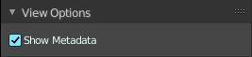

Show Metadata
Show metadata of first visible strip in the viewport.

Metadata panel

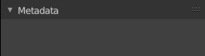
Display existing meta data of the selected strip(s).

